Assignment -4 Python Programming

|  |  |
| --- | --- |
| Assignment Date | 29 October 2022 |
| Student Name | ARAVINTH P |
| Student Roll Number | 142219106011 |
| Maximum Marks | 2 MARKS |

SMS SPAM CLASSIFICATION

Import the necessary libraries

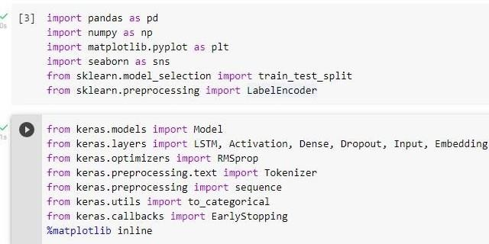

Download the Dataset

Dataset Downloaded and uploaded to drive [https://www.kaggle.com/code/kredy10/simple-lstmfor-](https://www.kaggle.com/code/kredy10/simple-lstm-for-text-classification/data) [textcl](https://www.kaggle.com/code/kredy10/simple-lstm-for-text-classification/data)assification/data

Read dataset and pre-processing

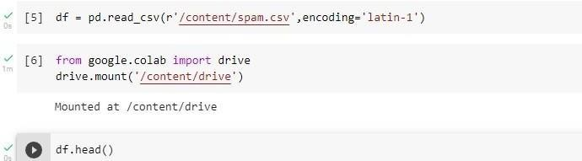

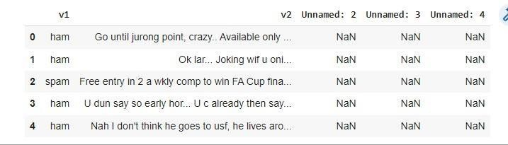

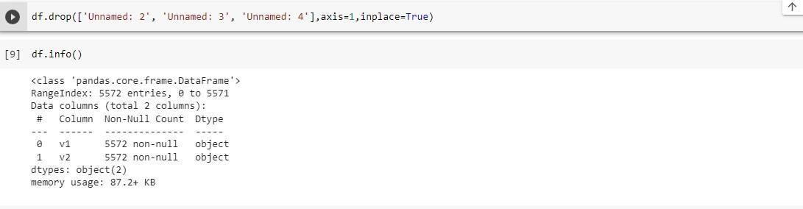

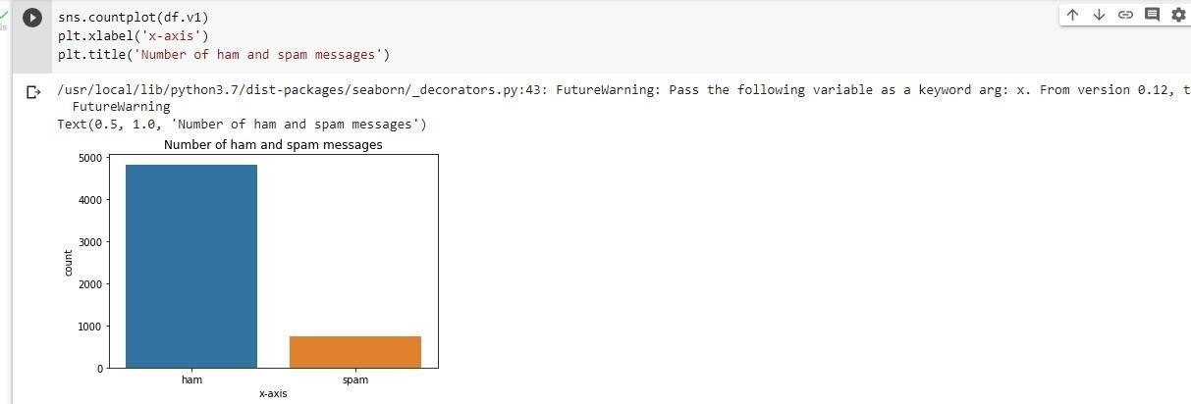

Create input vectors and process labels

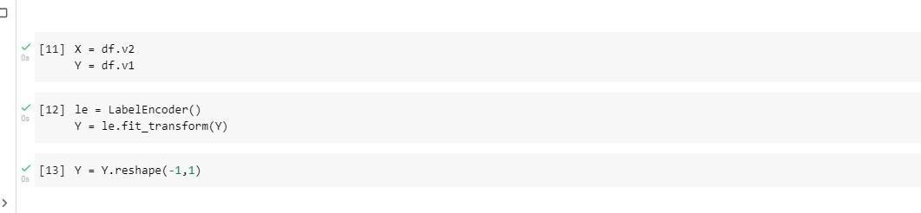

Split the training and testing data

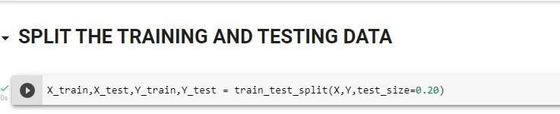

Process the data

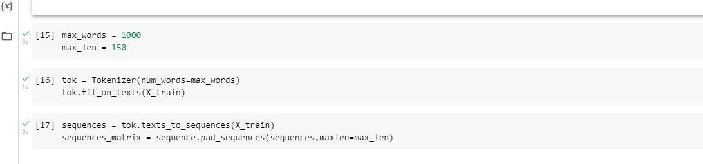

Create models and add layers

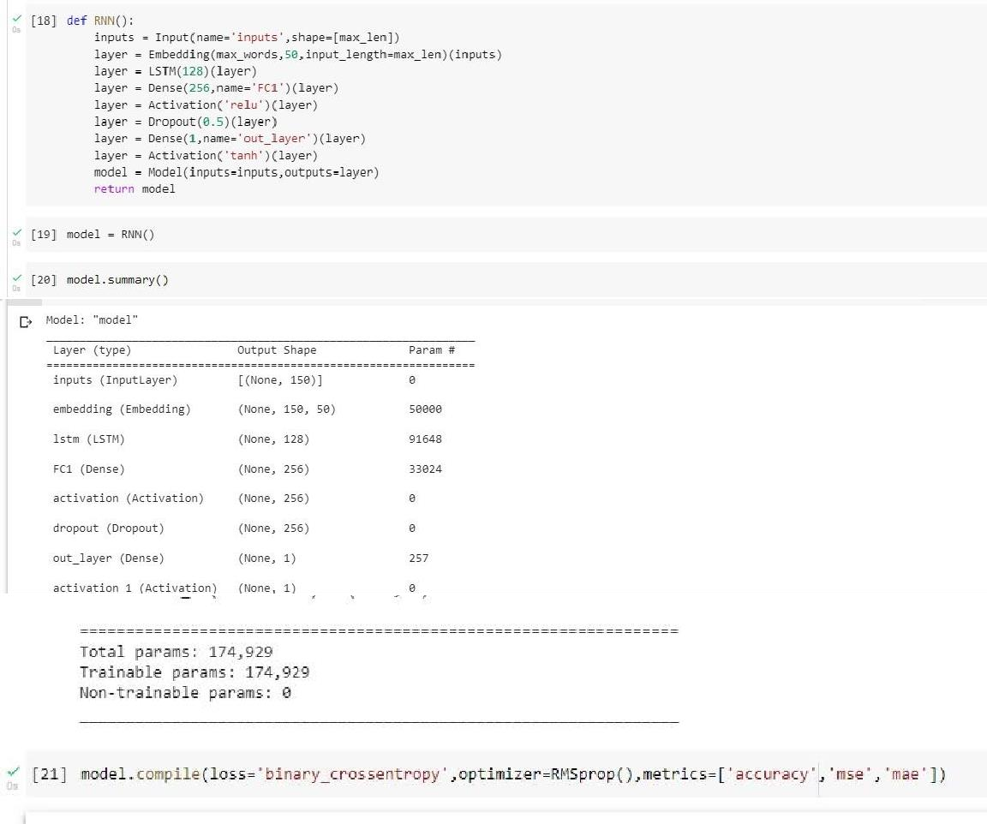

FIT THE MODEL

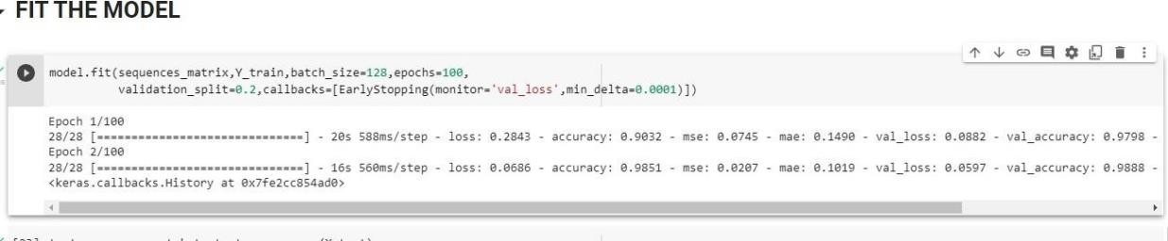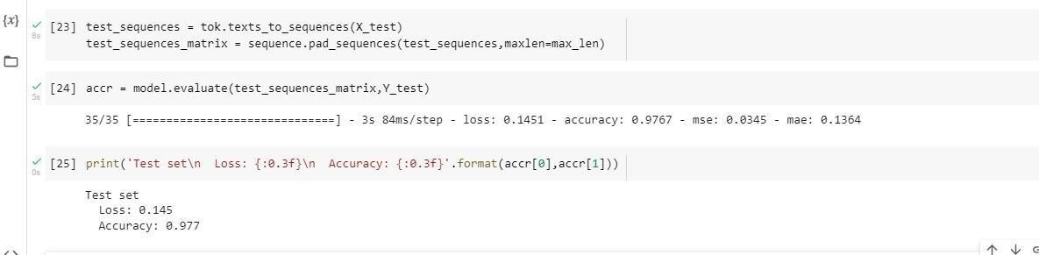

SAVE THE MODEL

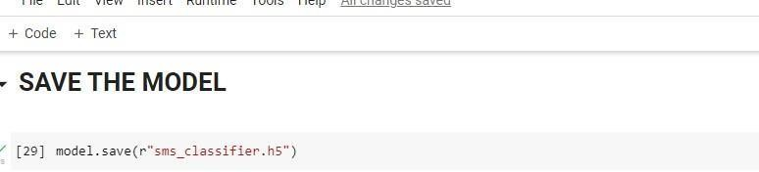

TEST THE MODEL

